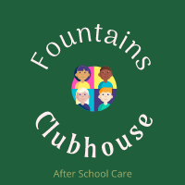

After School Care - Booking form – Summer 2023 – Term 1 (Until May half term)

Name of Child/Children………………………………………………………………..

Please put a tick in the dates you require:

Monday | 24th April | 15th  May | 22nd May
Tuesday | 18th April | 25th April | 2nd May | 9th May | 16th May | 23rd May
Wednesday | 19th April | 26th April | 3rd May | 10th May | 17th May | 24th May

