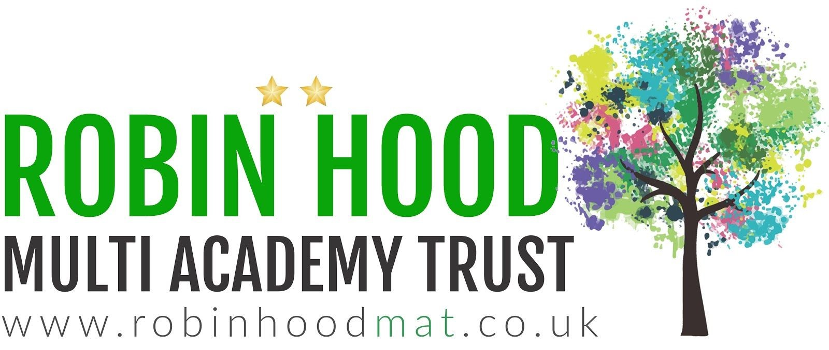
Learning Project - Famous & Significant People
Age Range: Y5/6
Weekly Reading Tasks | Weekly Spelling Tasks
Monday- Can somebody who is important to your child read to them? Perhaps​ they could share an extract from their favourite book or a poem? | Monday- ​Practise spellings on ​Spelling Frame​. Use a ​dictionary​ to clarify any unfamiliar vocabulary.
Tuesday- Encourage your child to read a newspaper article about a famous​ person. What can they tell about the person from the language used? Does the article criticise them or is it complimentary – how can they tell? | Tuesday- ​Choose 5 Common Exception words ​here​. Ask your child to write the meaning​, ​synonyms​ (word with the same/similar meaning) and antonyms​ ​ (word that has the opposite meaning) for each word.
Wednesday- ​Click ​here​ for a reading comprehension activity about a ​famous botanist​. Challenge your child to read the text in under 3 minutes and complete the comprehension questions. | Wednesday- ​Ask your child to mind map vocabulary that they associate with the following significant people: The Queen, ​Guy Fawkes​, ​Helena Lucas​ and ​Rosa Parks​.
Thursday- ​Visit​ ​Ducksters​ ​and encourage your child to choose a person that interests them to read about. Can they record 10 facts they discovered? | Thursday- ​Can your child complete ​this segment puzzle​ (click Spelling Tiles) which focuses on words ending in: ​-able, -ible, -ably and -ibly​?
Friday- Character profile. Ask your child to create a profile about a famous book​ character e.g. Harry Potter, Matilda Wormwood or Percy Jackson. | Friday- ​Pick 5 Common Exception words from the Year 5/6 spelling list ​here. Direct your child to represent each word as a picture.
Weekly Writing Tasks | Weekly Maths Tasks- Addition and Subtraction
Monday- ​Visit the Literacy Shed for this wonderful resource on ​The Clocktower​ ​or ask your child to write a letter/email to an important family member updating them on events from the last few weeks. | Monday- ​What different calculations can your child create when adding and subtracting the numbers ​111, 8276, 529, 18391, 9238​ and ​4163​? Make sure they check it is correct using the inverse operation.​CHALLENGE: Can you make some decimal numbers and ad these to one of the whole numbers.
Tuesday- ​Using the words ​FAMOUS PEOPLE​, get your child to write an acrostic poem about significant British people in history. | Tuesday- ​Encourage your child to play this ​online addition and subtraction game​. They can play it more than once to see if they can reach the top score.
Wednesday- ​Listen to Martin Luther King’s speech ​I Have a Dream​. Ask your child to write their own speech about their dreams​. ​Encourage them to use the same techniques such as repetition, personification and powerful verbs. | Wednesday- ​Play this ​missing box addition game​ or ​missing box subtraction game​. They can work on the level that adds/subtracts 3 digits by clicking on the orange three. Can they make their own addition/subtraction calculations like this?
Thursday- Create an information report about a significant/famous person of​ interest. Your child may choose a famous author, athlete, popstar or even a local | Thursday- Roll a dice and make a 6 digit number (target number). If you do not​ have a dice, make up a 6 digit number. Get your child to write 2 addition and 2
hero such as a doctor or nurse. Include: birthplace, what they’re most famous for, significant events/achievements and any other interesting facts. | subtraction calculations where the answer is the target number given. Make this easier by reducing the number of digits in the target number.
Friday- ​Following on from yesterday’s task, ask your child to​ ​write in role as that person and create a short autobiography of their life. Direct your child to think about the person’s emotions during key parts of their life. | Friday- Get your child to find out when each family member was born and record​ this. Ask your child to add all of the years up together and find a total. Add up the years from the same generation - which decade has the most/least members?

Learning Project - to be done throughout the week
The project this week aims to provide opportunities for your child to learn more about famous or significant people. Learning may focus on past or present inventors, explorers or scientists and how they influence society today.

- Famous Brits-​ Lots of significant people in history have been British. ​Emmeline Pankhurst​, ​Guy Fawkes​ and ​Mary Anning​ are just a few. Ask your child to research one of these or another famous Brit of their choice. They could create a fact file, a presentation, a chronological report of their life or present their research in any way they like.

- The Queen’s Speech- ​The Queen ​spoke to the nation​ on Sunday 5th April from Windsor Castle. She had an important speech to deliver where she wanted to thank people for what they were doing and to give hope that things would eventually return to normal. Ask your child to think about what they would say if they had to speak to the nation? What messages of hope would they want to give to their friends and family? Your child could write their speech or record themselves delivering their speech. Remember to tweet a video of their speech using​ ​#TheLearningProjects​.

- Inspiration for Inventors- ​These inventors​ talk about where they found the inspiration for their inventions. Ask your child what problems they incur in their daily life? What inventions would make their life easier? How could they ​turn their idea into a product?​ Direct your child to mind map ideas of how they could solve their problem before designing and annotating a product. Your child may even want to make a prototype or test parts of their design to see if it would work.

- Significant to Me- ​Discuss with your child a person who is significant to them. This could be a famous person who has inspired them or someone who has made a positive impact on them from their everyday life. Ask them to discuss the attributes that this person has - why are they inspiring? You could share someone who is significant to you with your child as well and talk about how they have influenced you. They may wish to draw a portrait of this person.

- What it Takes- ​Ask your child to watch ​this interview​ with Paralympic gold medallist Helena Lucas. In this interview it talks about the dedication needed to be a successful sportsperson. Direct your child to set themselves a goal to work on every day. They could create a poster outlining their goal and the steps they will take each day to work towards it. They may want to include steps they will take when they return to school.
STEM Learning Opportunities #sciencefromhome
Sophia Barnacle
- Sophia was a British inventor who invented the Helter-skelter in 1907. Try using junk box material to make your own helter-skelter or marble run.
- Try and make a run that takes exactly 60 seconds for the marble to complete the run. ● To find out more about building your own marble run click her​ e.​
Additional learning resources parents may wish to engage with
- BBC Bitesize​ - ​Lots of videos and learning opportunities for all subjects.
- Classroom Secrets Learning Packs​ ​- Reading, writing and maths activities for different ages.
- Twinkl​ - ​Click on the link and sign up using your email address and creating a password. Use the offer code UKTWINKLHELPS.
- White Rose Maths​ online maths lessons. Watch a lesson video and complete the worksheet (can be downloaded and completed digitally).
- Times Table Rockstars​ and ​Numbots​. Your child can access both of these programmes with their school logins. On Times Table Rockstars, children should​ aim to play Soundcheck for 20 minutes daily.
- IXL online. Click here for ​Year 5 or here for ​ ​Year 6​. There are interactive games to play and guides for parents.
- Mastery Mathematics Learning Packs. T​ ake a look at the mastery mathematics home learning packs with a range of different activities and lessons.
- Y5 Talk for Writing Home-school Booklets​ and ​Y6​ ​are an excellent resource to support your child’s speaking and listening, reading and writing skills.
The Learning Projects are based on the ​National Curriculum expectations​ for the key stage which your child is in. It may be that your child finds the tasks set within the Learning Project for their year group too simple. If this is the case, then we suggest that your child accesses the Learning Projects which are set for the key stage above. Equally, if the projects are too challenging, then we advise that your child accesses the projects for the key stage below.
If your child requires more of a challenge, or you believe that there are some gaps in their learning then​ ​Century Tech​ ​is a fantastic resource that is currently free for home learning. The app is designed to address gaps and misconceptions, provide challenge and enables children to retain new knowledge. It uses artificial intelligence to tailor the learning to your child’s needs. Sign up​ ​here​.
#TheLearningProjects
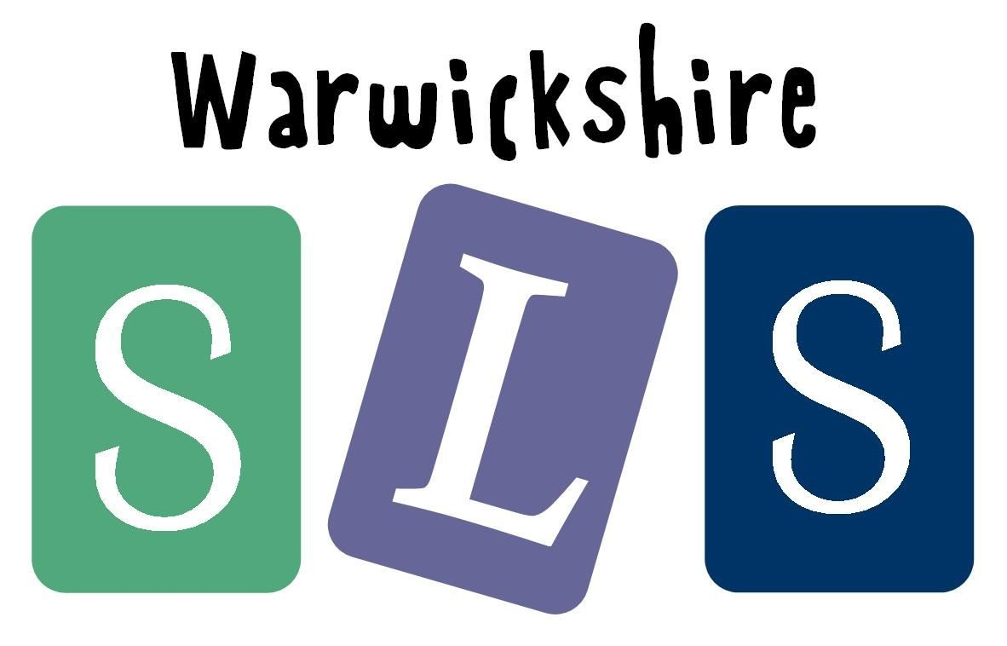
in collaboration with

www.robinhoodMAT.co.uk

