Monday’s Challenges Year 3 and Year 4
11.1.20
Y3 Reasoning and Problem Solving : Make equal groups Sharing
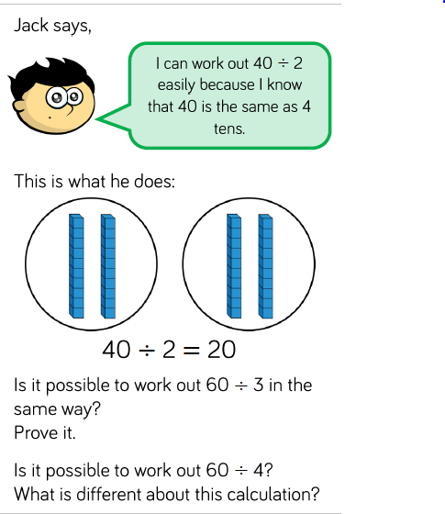
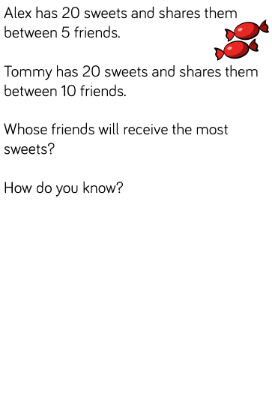

Y4 Reasoning and Problem Solving : Divide by 10
