[](https://www.google.com/url?sa=i&url=https%3A%2F%2Fwww.pinterest.co.uk%2Fpobbleeducation%2Ffree-daily-writing-prompts-story-starters-pobble-3%2F&psig=AOvVaw3O8ur0PD3zO3othHSlEGRZ&ust=1585596296640000&source=images&cd=vfe&ved=0CAIQjRxqFwoTCJC_mK77v-gCFQAAAAAdAAAAABAa)[](https://www.google.com/url?sa=i&url=http%3A%2F%2Fwww.pobble365.com%2Fa-new-world-2&psig=AOvVaw3O8ur0PD3zO3othHSlEGRZ&ust=1585596296640000&source=images&cd=vfe&ved=0CAIQjRxqFwoTCJC_mK77v-gCFQAAAAAdAAAAABAS)[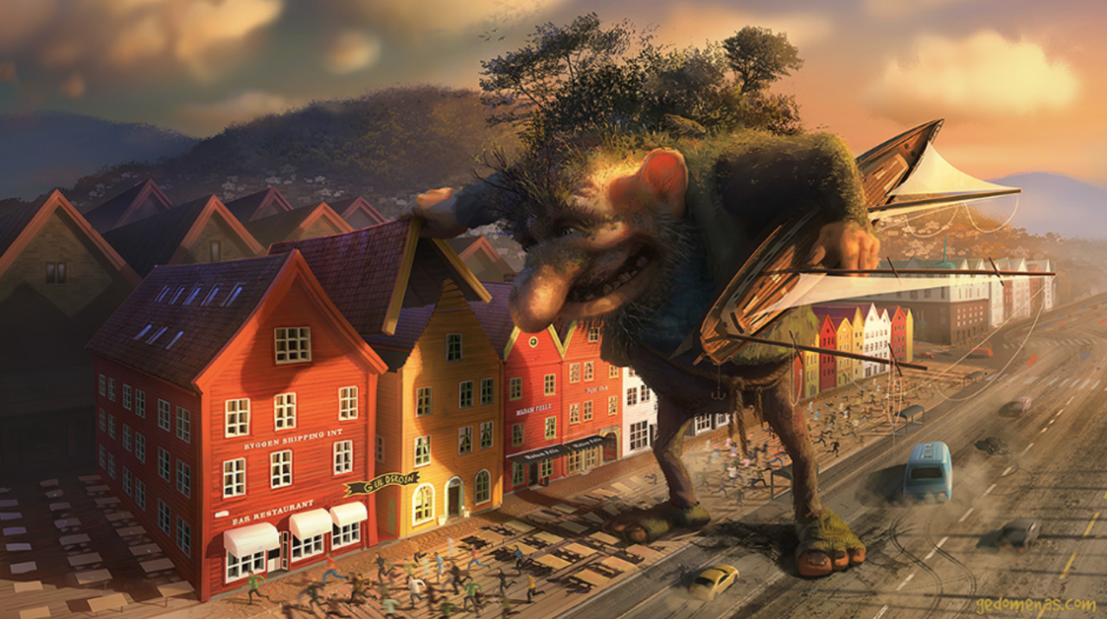](https://www.google.com/url?sa=i&url=http%3A%2F%2Fwww.pobble365.com%2Fthe-troll&psig=AOvVaw3O8ur0PD3zO3othHSlEGRZ&ust=1585596296640000&source=images&cd=vfe&ved=0CAIQjRxqFwoTCJC_mK77v-gCFQAAAAAdAAAAABAL)