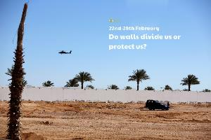 

Sharm El-Sheik is a popular holiday destination. If possible, look at some holiday brochures. We can usually find some online. Can you find details about the location, weather, hotels, activities and price? Are there any pictures with captions? What headings or sub-headings are used? Can you find any persuasive language? Create your own brochure to advertise your favourite holiday destination. If you don’t have one, you can make it up!

Not all walls are physical. Can you think of any examples? Have you ever heard someone say they’ve hit the wall during a run? What might an emotional wall be?

Read and research famous walls built in the past. When, where and why were they built? Have you ever visited any historical walls?

A mural is a painting or piece of art applied directly onto a wall. Design a mural for a wall at school or for a wall in your bedroom!

The walls in our homes are positioned to separate the different rooms. The distance all the way around the edge of one of your rooms is called the perimeter. Measure the perimeter of one of your rooms. If you don’t have a tape measure or a metre ruler, could you use a non-standard unit of measurement such as your own feet? What would be the perimeter of these rectangular rooms? 5m x 7m, 9.5m x 6m, 4.5m x 3.5m

Create a word wall of amazing vocabulary linked to this week’s image. Record each word on a brick (post it note or piece of paper) and then display them by building your wall. Use your vocabulary to write a descriptive sentence.

**Learning from home**

Use the ideas below, alongside this week’s resource, to support your home learning.