Cube Challenge

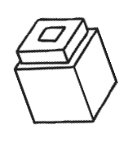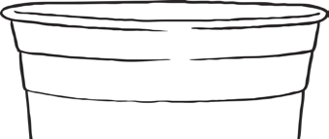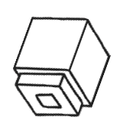

I can use non-standard units to measure capacity.

Collect some small containers and a resource you can fill it will. For example, cubes, beads, buttons, blocks

Choose a container. How many cubes do you think it will hold?

Test to see if you are right.

|  |  |  |
| --- | --- | --- |
| Container | Prediction | Result |
| Mug | Le Creuset® Official Site | **12**  Lego bricks | **10**  cubes |
|  |  |  |
|  |  |  |
|  |  |  |
|  |  |  |