Christmas events at Fountains CE Primary School

Wednesday 6th December in the school hall from 2:30-4pm

Monday 11th December- Christmas Craft Night from 3:30 to 5pm.

Thursday 14th December – Christmas Jumper day and Christmas lunch.

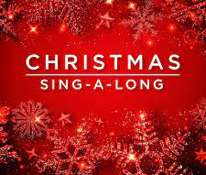

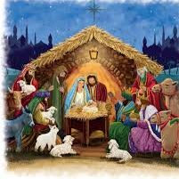
Tuesday 19th December – Christmas sing-along with Emily Roberts – Time TBC

Wednesday 20th December – Whole school Christmas Performance 2pm and 5:30pm

Thursday 21st December – Carol Service at Sawley Church – 2:30pm

Friday 22nd December - Christmas Parties – all classes. Times TBC.

