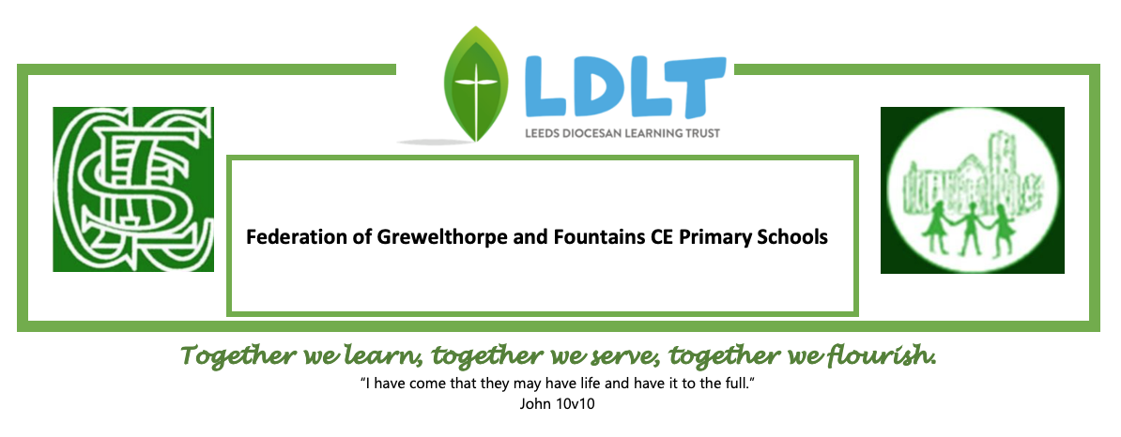 Statement of Intent

Design and Technology (DT)
2023-2024

Intent
Our overall intent is that pupils are able to be innovative and creative thinkers, who have an appreciation for the product design cycle and an awareness of the impact of design and technology in the world today. We will aid them to achieve this by:
- Providing opportunity to fully engage in the design thinking process throughout the six key areas.
- Giving opportunities to allow identification of processes that may have already taken place in the creation of current products.
- Developing their awareness of potential environmental effects in product design and creation. For example, sustainability, seasonality and the carbon footprint of food.
- Transferring skills from other subjects such as mathematics, art and science to enhance their learning.

Impact
Our schools hope that with a growing design technology awareness, our children will become resourceful and enterprising individuals who have the skills, knowledge and confidence to contribute to future design advancements to benefit our world.

Implementation
We teach our units using a cyclic curriculum and aim to build on the cultural capital of the school by linking some DT projects with societal events. Other projects are linked to cross curricular subjects. Our long-term planning grid shows how we build progression into our learning and provide further opportunities to build upon knowledge gained. Pupils enter a 2-year rolling programme at different points it is important that children have the opportunity to revisit learning in order to help retain knowledge.
Teachers use the DT association ‘Projects on a Page’ scheme of work to aid with the teaching of each area of the curriculum. The DT association progression framework is also followed to ensure a building of skills from KS1 To UKS2.

The six key areas for design and technology are: cooking and nutrition, mechanisms/mechanical systems, structures, textiles, electrical systems and the digital world.
Cooking and nutrition
- Where food comes from, balanced diet, preparation and cooking skills
- Kitchen hygiene and safety
- Following recipes
Mechanisms/Mechanical systems
- Mimic natural movements using mechanisms such as: cams, followers, levers and sliders
Structures
- Material functional and aesthetic properties, strength and stability, stiffen and reinforce structures
Textiles
- Fastening, sewing, decorative and functional fabric techniques including cross stitch, blanket stitch and appliqué
KS2 only:
Electrical systems
- Operational series circuits, circuit components, circuit diagrams and symbols, combined to create various electrical products.
Digital world
- Program products to monitor and control, develop designs and virtual models using 2D and 3D CAD software

The design process has three main stages: design, make and evaluate. Each stage can be revisited at any time during a project. Furthermore, the confidence and understanding to be able to revisit each on several occasions over a project will allow successful and innovating design and creation.
Design
- Research
- Design criteria (e.g. tailoring to an audience/user)
- Idea generation (e.g. annotated sketches)
- Idea development (e.g. templates, pattern pieces.)
- Models and prototypes (both virtual and physical)
- Cross-sectional and exploded diagrams
- Innovative, fit-for-purpose and functional product solutions to design problems
Make
- Select and use appropriate tools and equipment
- Understand and select materials and components (including ingredients) based on their aesthetic and functional properties
- Carry out practical tasks with increasing accuracy and precision
- Understand the importance of, and follow the health and safety rules
Evaluate
- Explore existing products
- Evaluate against a list of design criteria
- Evaluate, investigate and analyse existing products
- Evaluate their own and others’ ideas
- Understand how key events and individuals have helped to shape the world of D&T
- Consider feedback to make improvements
Cooking and nutrition
This has a separate section in the D&T national curriculum, with additional focus on specific principles, skills and techniques in food, including where food comes from, diet and seasonality.
Food units follow the design process for example by tasking the pupils to develop recipes for a specific set of requirements (design criteria) and to suggest methods of packaging the food product including the nutritional information.
EYFS
The Characteristics of Effective Learning are the bedrock of children’s experiences within EYFS in all areas of learning. They include:
Playing and exploring | Active learning | Creating and thinking critically
• finding out and exploring  • using what they know in their play  • being willing to have a go | • being involved and concentrating  • keeping on trying  • enjoying achieving what they set out to do | • having their own ideas  • using what they already know to learn new things  • choosing ways to do things and finding new ways

These characteristics form the first steps in preparing our youngest children in their learning about design and technology. They link with the attributes included below to allow EYFS learning to link to that which follows in Key Stage 1 and Key Stage 2.
Reception Development Matters 2020  (Children in Reception) | Early Learning Goals
Personal, Social and Emotional Development  Show resilience and perseverance in the face of challenge  Manage their own needs. - personal hygiene  Know and talk about the different factors that support their overall health and wellbeing: - healthy eating | Personal, Social and Emotional Development  Self -Regulation  Set and work towards simple goals  Managing Self  Persevere in the face of challenge  Manage their own basic hygiene and personal needs  Understanding the importance of healthy food choices
Physical Development  Develop their small motor skills so that they can use a range of tools competently, safely and confidently. Suggested tools: pencils for drawing and writing,  paintbrushes, scissors, knives, forks and spoons | Physical Development  Fine Motor Skills  Use a range of small tools, including scissors, paintbrushes and cutlery  Begin to show accuracy and care when drawing
Understanding the World
The Natural World
Understand some important processes and changes in the natural world around them
Expressive Arts and Design  Return to and build on their previous learning, refining ideas and developing their ability to represent them  Create collaboratively, sharing ideas, resources and skills | Expressive Arts and Design  Creating with materials  Safely use and explore a variety of materials, tools and techniques, experimenting with colour, design, texture, form and function  Share their creations, explaining the process they have used  Make use of props and materials when role playing characters in narratives and stories.

