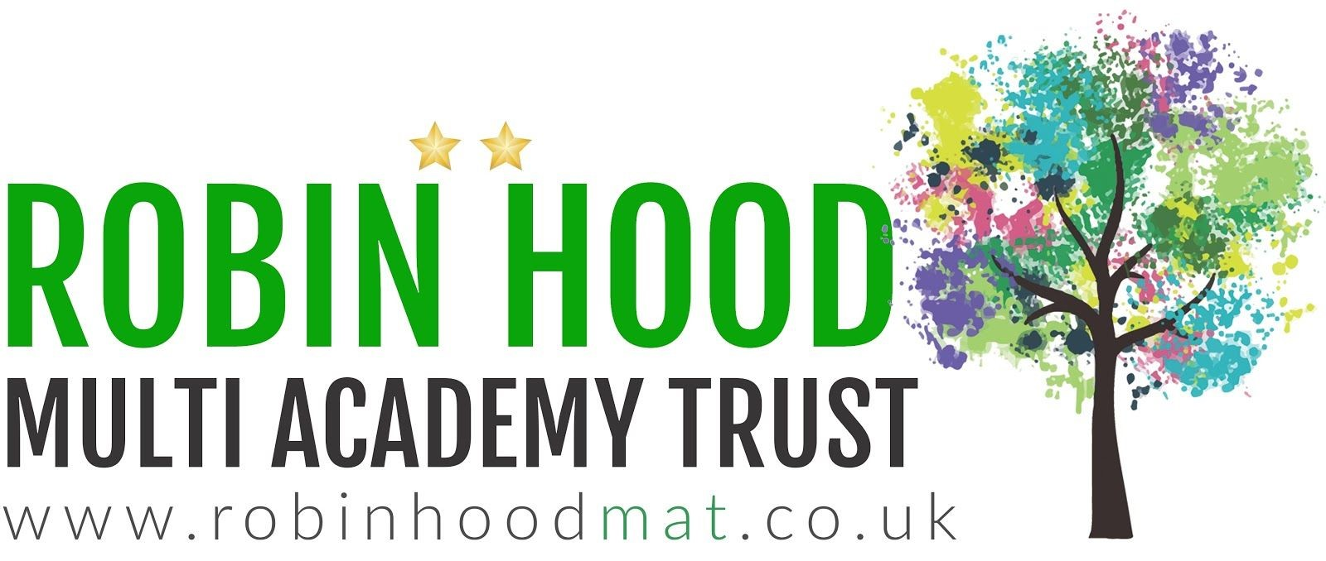
Learning Project - Music
Age Range: Y3/4
Weekly Reading Tasks | Weekly Spelling Tasks
Monday- ​Look with your child at ​this​ poster pack of musical styles. Read through the information for each musical style and find a song to listen to. Ask your child to identify their favourite music styles giving reasons for their choice. | Monday- ​Ask your child to learn to spell the names of an instrument from each of the instrument families (​strings, woodwind, brass, keyboards, and percussion).
Tuesday- ​Ask your child to find the lyrics to their favourite song and highlight some creative words used, finding out the meaning of new words​. | Tuesday- ​Practise spelling these words: ​measure, treasure, pleasure, enclosure​. Can your child write a definition for each of these words?
Wednesday- Do you have any CDs or records in the house? If so, ask your child​ to organise them in alphabetical order or by genre. If not, provide them with a list of musicians where they can do the same thing. | Wednesday- ​Ask your child to unscramble these musical words: ​empot, demloy, epslu, narhmoy & rrecsttuu.
Thursday- ​Visit​ ​Audible​ and let your child choose a book to listen to. Ask them to write a review when they have finished (free audio books available). | Thursday- ​Memory.​ Write as many of your spellings down from memory as you​ can. How many did you recall? Practise any you have missed.
Friday- ​Your child can listen to BBC School Radio music episodes ​here​. These episodes are based on Treasure Island and your child will learn new songs. | Friday- ​Practise the Y3/4 spellings in ​this fun,interactive way​. Encourage your child to note down any words they are unfamiliar with and clarify them.
Weekly Writing Tasks | Weekly Maths Tasks- Shape
Monday- ​Visit the Literacy Shed for this wonderful resource on ​Once in a Lifetime or take part in a writing ​masterclass​. | Monday- ​Encourage your child to watch ​this video ​about angles and learn the names of different angles such as right angles, obtuse and acute angles.
Tuesday- Listen to the piece of music called ​ Peter and the Wol​ f,​ written by Prokofiev. Whilst listening, encourage your child to list any words that come to mind e.g elation, cheerfulness. They could also draw a picture of what they think the song represents. | Tuesday- Ask your child to become a shape scavenger! How many examples of​ different 2D and 3D shapes can they find around the home/garden? Can they create a tally and sort the shapes they find based on their properties? e.g. number of sides/edges, number of pairs of parallel lines.
Wednesday- Now read the story​ . ​ Ask your child to write their own story that would be great told through music or draw a story map to represent this tale. Can they include speech too? | Wednesday- Ask your child to write their name in capital letters and see how​ many angles they can see in each letter. How many right angles? How many acute and obtuse angles? Repeat for other family names.
Thursday- Your child can make a mini-book about the instrument families.​  Include: names of instruments within that family, famous musicians who use them, | Thursday- Last week your child wrote a times table song. Ask your child to​ rehearse their song but this time incorporate a beat using a musical instrument
country of origin and labelled illustrations. | (see below).
Friday- Invent a new instrument. Ask your child to write a fact file about their​ instrument or design an advert for when the instrument goes on sale. | Friday- Practise multiplying multiples of 10 using known facts and place value, e.g.​ 70 x 3 = 210, I also know that 3 x 70 = 210.

Learning Project - to be done throughout the week
The project this week aims to provide opportunities for your child to learn more about music. Learning may focus on famous musicians, listening to and performing music and exploring a range of music genres and instruments.

- Lean On Me - Encourage your child to listen to ​ Lean On M​ e, a Soul/Gospel song by Bill Withers. Do they like it? What instruments can they hear? Can they​ clap a rhythm? Learn to sing the lyrics and have a go at performing the song. Perhaps your child would like to research this famous artist in more detail and listen to more of his songs, creating an artist profile complete with portrait sketch. Perhaps they could perform the song to a family member via Facetime (with adult supervision)? Share your performance at #TheLearningProject​ .​

- Musical Makes - Ask your child to try creating their own music instrument. They could make their own pan flute using straws, a cereal box guitar, or​ some tin can drums. Encourage them to plan their design first, source materials from around the house, write the steps to make the product and then evaluate it afterwards. Or they could research Kandinsky and create their own instrument art inspired by his work whilst listening to different genres of music.​

- Feel the Beat - Why not ask your child to have a go at moving their body to different genres of music. As you change between Rock, Jazz, Hip Hop, Heavy​ Metal and Classical music, how does the way they move their body change? Have a dance together to the beat of the music! Recommendation at least 2​ hours of exercise a week.

- Listen Together - Encourage your child to ask each family member what their favourite song is. Play the song aloud and listen together. Spend some time as a​ family discussing what genre of music the songs belong to and how each piece of music makes you feel. Which genres of music were the most popular? Can your child represent their results in a bar chart. They could ask family members to rank their favourite genres of music first.

- Musical Movie Time - Allow your child to choose an age-appropriate musical to watch. Andrew Lloyd Webber is now posting filmed versions of his shows on​ his Youtube channel The Shows Must Go On!​ each week! Discuss the story behind the musical and ask your child to step into the shoes of different characters​ and imagine how they are feeling. Which is your child’s favourite song from the film/show and why? Can they create a billboard poster advertising the show? Or perhaps design a ticket?
Coronavirus and Wellbeing- Returning to/Being at School
The change that Covid-19 has caused to our lives has been difficult and has provided countless challenges. For many children, the uncertainty and disruption to everyday life has caused worry and anxiety. These tasks are designed to help children process the current situation, begin to make sense of it and plan for returning to a different normal.

Think
● Inevitably, your child is likely to have many questions about the Coronavirus, how to stop the spread and what will happen next. This eBoo​ k answers many of​ the questions and is a helpful starting point for a discussion around their concerns, particularly if they are returning to school soon.
Talk

- School is going to look very different for all children, parents and staff. Social distancing is going to provide an extra challenge for learning. Plan ways that you can still be social whilst social distancing by asking your child to draw illustrations e.g smiling back at people when they smile at you or asking people how they are feeling.
Do
- As well as feeling excited, your child may have many worries about returning to/ being at school. Complete a problem planner with your child, thinking about what their worries are, scaling how concerned they are about each specific problem and planning steps to support any concerns. This templat​ e may help.​
Visit
- Childline has a bank of activities to encourage your child to share their worries. ​ This factshee​ t ​ explains anxiety in a suitable way for children.
STEM Learning Opportunities #sciencefromhome
Making Instruments
- You will need a jar/bottle, some water and a pencil. Try tapping the side of an empty container with a pencil. What type of sound does it make? Partially fill the container with water, tap the container again. Has the sound changed? Try filling the container with different amounts of water. Can you play a tune? Look her​ e.​
- Now try making a straw oboe. All you need is a drinking straw and some scissors. Cut the end of the straw into an arrow shape and blow gently. Once you get a duck type sound try altering the length of the straw. What do you notice? ● For more ideas take a look at the full resources her​ e.​
Staying Safe Online
Staying safe online is called 'digital literacy' and this means​ having the skills and knowledge to use the internet safely and responsibly. It is where someone can manage online content and communication, spot possible risks, and find ways to protect themselves from these risks. You can find out more by visiting Childnet​.
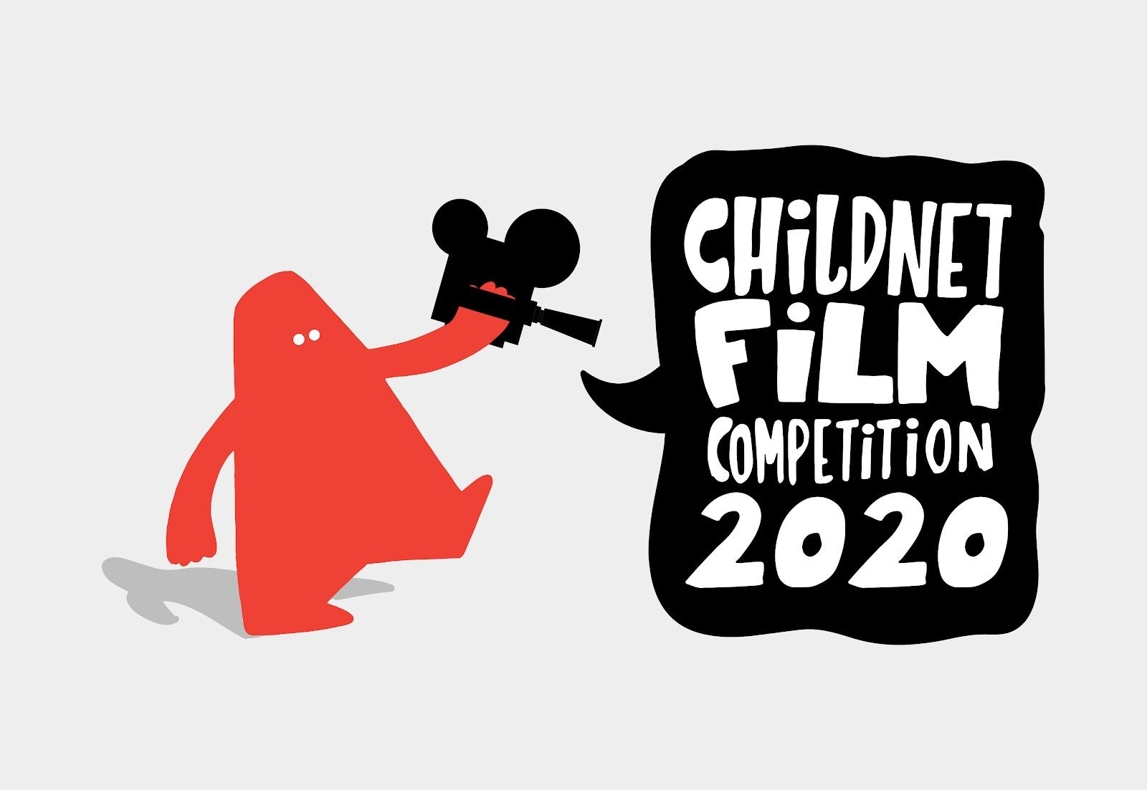
Your child could have a go at entering ​The Childnet Film Competition​ which invites young people aged 7-18 to create a 2 minute online safety film to inspire their peers to create a safe, supportive and fun online world around the theme ‘​We want an internet where we’re free to…​’ The entries that make into the final shortlist will be judged by a prestigious panel made up of representatives from BAFTA, the BBC, the British Board of Film Classification, the BFI, Disney and the Motion Picture Association. The young people who create winning films and storyboards will receive great filmmaking and creative prizes for their school or youth group. Whether used at school or as a home learning project, the competition is a great way of exploring important internet safety messages with young people of all ages. Find out more ​here​.
Additional learning resources parents may wish to engage with
- BBC Bitesize​ - ​Lots of videos and learning opportunities for all subjects.
- Classroom Secrets Learning Packs​ ​- Reading, writing and maths activities for different ages.
- Twinkl​ - ​Click on the link and sign up using your email address and creating a password. Use the offer code UKTWINKLHELPS.
- White Rose Maths​ online maths lessons. Watch a lesson video and complete the worksheet (can be downloaded and completed digitally).
- Times Table Rockstars​ and ​Numbots​. Your child can access both of these programmes with their school logins. On Times Table Rockstars, children should​ aim to play Soundcheck for 20 minutes daily.
- IXL online. Click here for ​Year 3 or here for ​ ​Year 4​. There are interactive games to play and guides for parents.
- Mastery Mathematics Learning Packs. T​ ake a look at the mastery mathematics home learning packs with a range of different activities and lessons.
- Y3 Talk for Writing Home-school Booklets​ and Y​ 4 ​ are an excellent resource to support your child’s speaking and listening, reading and writing skills.​
The Learning Projects are based on the ​National Curriculum expectations​ for the key stage which your child is in. It may be that your child finds the tasks set within the Learning Project for their year group too simple. If this is the case, then we suggest that your child accesses the Learning Projects which are set for the key stage above. Equally, if the projects are too challenging, then we advise that your child accesses the projects for the key stage below.
If your child requires more of a challenge, or you believe that there are some gaps in their learning then​ ​Century Tech​ ​is a fantastic resource that is currently free for home learning. The app is designed to address gaps and misconceptions, provide challenge and enables children to retain new knowledge. It uses artificial intelligence to tailor the learning to your child’s needs. Sign up​ ​here​.
#TheLearningProjects
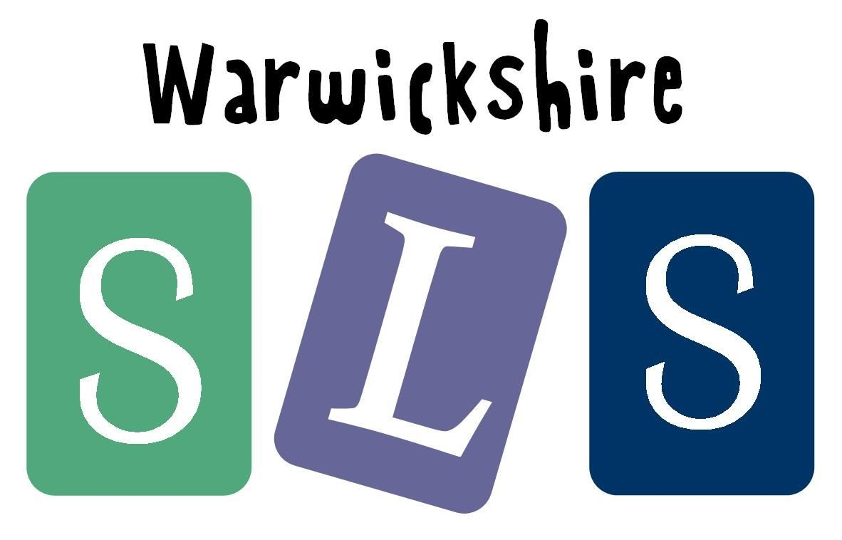
in collaboration with

www.robinhoodMAT.co.uk

