Winter Cupcakes
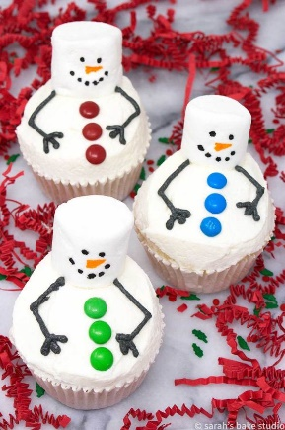
Ingredients
For the cakes  - 110g softened butter  - 110g caster sugar  - 2 large eggs  - ½ tsp vanilla extract  - 110g self-raising flour | For the buttercream  - 150g softened butter  - 300g icing sugar  - 1 tsp vanilla extract  - 3 tbsp milk  - Marshmallow for the head  - Smarties or small sweets for the buttons  - Food colouring paste for arms and face
- STEP 1 Heat oven to 180C/160C fan/gas 4 and fill a 12 cupcake tray with cases.
- STEP 2 Using an electric whisk beat 110g softened butter and 110g golden caster sugar together until pale and fluffy then whisk in 2 large eggs, one at a time, scraping down the sides of the bowl after each addition.
- STEP 3 Add ½ tsp vanilla extract, 110g self-raising flour and a pinch of salt, whisk until just combined then spoon the mixture into the cupcake cases.
- STEP 4 Bake for 15 mins until golden brown and a skewer inserted into the middle of each cake comes out clean. Leave to cool completely on a wire rack.
- STEP 5 To make the buttercream, whisk 150g softened butter until super soft then add 300g icing sugar, 1 tsp vanilla extract and a pinch of salt.
- STEP 6 Whisk together until smooth (start off slowly to avoid an icing sugar cloud) then beat in 3 tbsp milk.
- STEP 7 Spread the buttercream on your cake and add sweets to make your snowman.

