Parents/carers

Drop in session for parents/carers with the Inclusive Education Service (IES), Communication and Interaction Team (C&I).

Bilton Children’s Centre, Woodfield Road, Harrogate

Tuesday afternoons between 1.30 pm - 4.00 pm
Dates: 05.11.19; 19.11.19; 03.12.19 & 17.12.19

Two members of the C&I team will be available to offer guidance and support on the following areas:

Language and Communication

Social Skills and Understanding

Peer Interaction

Emotional Regulation

Sensory Processing
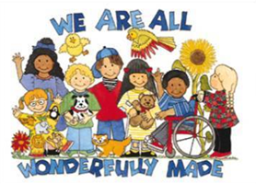

If you would like further support and advice please come along.
We look forward to meeting you.

Contacts: samantha.gray@northyorks.gov.uk or emma.bibby@northyorks.gov.uk

