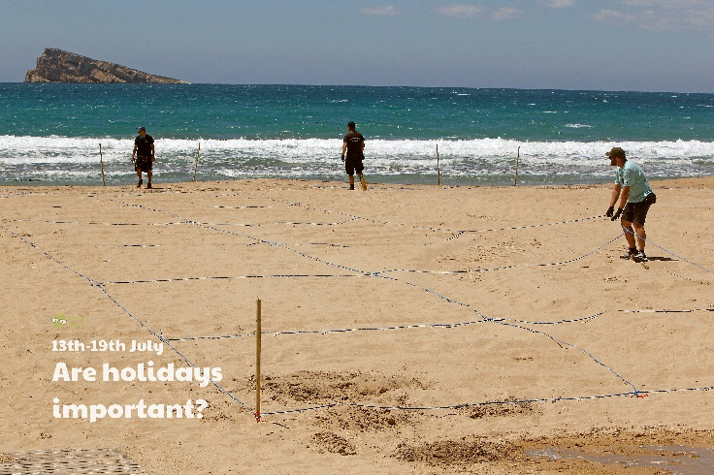

Make a list of things you would pack in your suitcase to go on holiday. Are you going somewhere hot or cold? What will you need to take in your wash bag? Do you have anything special you need to pack e.g. a toy or a teddy? Look back at your list of items. If you could only take one item on holiday with you, what would it be?

Draw a picture of an activity you would like to do whilst you were on holiday.

Imagine you are going on holiday tomorrow. Choose your destination then find its weather forecast. Can you present the forecast? You could even make weather symbols and video it!

Make a list of 5 countries you might like to go on holiday. Locate them on a world map. Find out what language is spoken there and how to say ‘hello’.

If you travel on an aeroplane to another country, your suitcase has to be a certain size and a certain weight so they can fit it on. The length of the suitcase is usually measured in centimetres and the weight is usually measured in kilograms. British Airways have a maximum suitcase length of 90cm. Can you find anything in your classroom or at home that is about 90cm? Measure the length of a bag or suitcase, would you be allowed to take it on the aeroplane? Use the sheet found in the home learning section to explore this further.

Write a setting description of your dream holiday. Where is it? The coast, mountains, forest, sea? What can you see? What can you hear? What can you smell? How do you feel?

**Learning from Home**

Use the ideas below, alongside this week’s resource, to support your home learning.