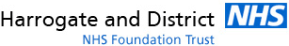
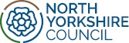

North Yorkshire Council
County Hall
Northallerton
North Yorkshire
DL7 8AD
www.northyorks.gov.uk
17.01.2024

Dear Parent or Carer

Height and weight checks for children in Reception and Year 6
Every year in England, school children in reception and year 6 have their height and weight checked at school as part of the National Child Measurement Programme (NCMP). Height and weight measurements are used to calculate weight status. We collect this information to build a picture of how children are growing to help plan better health and leisure services for families. Your child’s class will take part in this year’s programme.

The checks are carried out by trained health care providers. Children are measured fully clothed, except for their coats and shoes, in a private space away from other pupils and school staff.

The programme will be delivered in a safe way, in line with the school and local authority’s safety control measures and national guidance. Once the measurements have been carried out, you will get a letter with the results (only you as the parent/carer will receive the results - it is your choice if you share them with your child). You may also be contacted by the family health assistants who will talk through your child’s results and offer advice and support.

Further details are provided in the pages below, including what data is collected and how it is used. Here is a link to a new video made by the North Yorkshire NCMP team: The National Child Measurement Programme - YouTube

If you are happy for your child to be measured, you do not need to do anything.

If you do not want your child’s height and weight to be measured, or if your child has a medical condition that affects their height or weight or ability to be measured, please let us know using the contact details below. Please note: opting out your child will only apply to this particular child in this particular year. Also, children will not be made to take part on the day if they do not want to.

HDFT 0–19 Children’s Services: 0300 3030916 nationalchild.measurementprogramme@nhs.net

Yours faithfully,
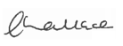
Louise Wallace, Director of Public Health, North Yorkshire Council
What will happen on the day?
The family health assistant will visit me at school to check how I’m growing and staying healthy
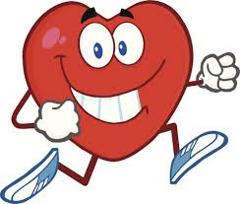

The family health assistant will visit my classroom to say hello
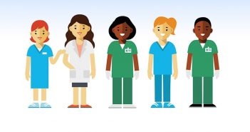

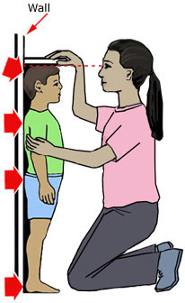
My teacher will take me to the room where the Family health assistant asks me to stand next to a BIG ruler to see how tall I am

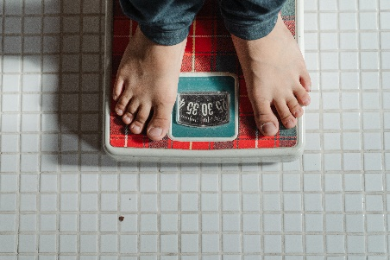
Then I stand on a little platform that tells the family health assistant how much I weigh

The family health assistant writes all my information down and then I go back to my class

Further Information
Local contacts for the National Child Measurement Programme in North Yorkshire:
- HDFT 0–19 Children’s Services Single point of Contact: 0300 3030916 nationalchild.measurementprogramme@nhs.net
- Helen Ingle, Public Health Manager, Public Health Team (NYCC) helen.ingle@northyorks.gov.uk

About the NCMP

Further information about the National Child Measurement Programme can be found at:

https://www.nhs.uk/live-well/healthy-weight/national-child-measurement-programme
https://healthyschoolsnorthyorks.org/ncmp/

Information and fun ideas to help your kids stay healthy can be found at
https://www.nhs.uk/healthier-families/

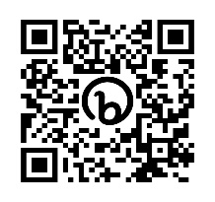
Another way to help maintain a balanced diet and physical activity for your family is the NHS Healthy Steps email programme. Sign up for the 8-week Healthy Steps emails and you will be sent lots of low-cost easy tips, fun games, healthy swaps and tasty recipes on a budget.
Scan the QR code or visit healthysteps.uk to sign up.

Information about how we (Harrogate and District NHS Foundation Trust 0 - 19 Children’s Services) collect and use information can be found at https://www.hdft.nhs.uk/privacy-notices/patients-privacy-notice/
Information about how NHS England and Office for Health Improvement and Disparities collect and use information can be found at https://digital.nhs.uk/about-nhs-digital/our-work/keeping-patient-data-safe/how-we-look-after-your-health-and-care-information and https://www.gov.uk/government/organisations/department-of-health-and-social-care/about/personal-information-charter

Information about the organisations NHS England has shared information from the National Child Measurement Programme can be found at https://digital.nhs.uk/services/national-child-measurement-programme

Maintaining the well-being of children in the NCMP

The wellbeing of children and families is very important. NCMP measurements are conducted in a sensitive way, in private and away from other children. Individual results are not shared with your child or their school. The weight and height information is shared only with you in the parent or carer feedback letter. It is your choice if you share the information with your child.
The emotional impact of the NCMP has been researched and studies show that body image, self-esteem, weight-related teasing and restrictive eating behaviours do not change as a result of being measured or receiving feedback. If you are concerned about your child’s growth, weight, body image or eating patterns, seek further support from your General Practitioner.
The information we collect and what it is used for is listed below:

- your child’s date of measurement, sex and date of birth are used to calculate your child’s weight category
- your child’s name, date of birth and NHS Number are used to link your child’s measurements in Reception and Year 6.
- Other data sets held by NHS Digital and Department of Health and Social Care, may also be linked as this would let us add information from health and education records, where lawful to do so, to understand how and why the weight of children is changing, and how this affects children’s health and education and how we can improve the care children receive.
- your child’s ethnicity and address are used to help understand some of the reasons for the difference and changes in child weight across England
- your address is required to send you your child’s feedback letter. This will include your child’s measurements together with information about healthy eating, being active and related activities available in your area.
- your email address and telephone number are required as we may contact you by email or telephone to discuss your child’s feedback/send you your child’s feedback letter by email/offer you further support following your child’s measurement.
- All the data collected is also used for improving health, care and services through research and planning.
- All this information is treated confidentially and held securely. No individual measurements will be given to school staff or other children.

How the data is used

- The information collected from all schools in the area will be gathered together and held securely by North Yorkshire County Council. We will store your child’s information as part of their local child health record on the NHS’s child health information database (your GP may have access to this).
- All the information collected about your child will be sent by us to NHS Digital. NHS Digital is responsible for collecting data and information about health and care so that this can be used to monitor and improve the care provided to people across England.
- The information collected about your child will also be shared by NHS Digital with the Office for Health Improvement and Disparities (OHID) which is part of the Department of Health and Social Care (DHSC) but in a de-personalised form only.
- Both NHS Digital and the Office for Health Improvement and Disparities (DHSC) will use the information from the National Child Measurement Programme to better understand numbers and trends in child weight and body mass index (BMI). This helps with the planning of services to support healthy lifestyles in your area. No information will ever be published by NHS Digital or the Office for Health Improvement and Disparities (DHSC) that identifies your child.
- De-personalised information from the National Child Measurement Programme may also be shared by NHS Digital with other organisations, such as universities. This is to help improve health, care and services through research and planning. This information cannot be used to identify your child, and NHS Digital only ever shares information for research with the approval of an independent group of experts.

